**Weather websites:**

* BKB Kiteboarding <http://www.bellinghamkiteboarding.com/wind.php>
  + We usually check the Locust beach sites (now Locust beach west and Bellingham). Note that if you click on the graph, it takes you to Ikitesurf. From there you can click on a variety of different sensors around the area.  Check out the forecast to see what is predicted. Sometimes it is spot on, but first check current conditions against the forecast. If it’s already above the forecast, and predicted to get windier, then that is likely the trend.
  + Look at the Smith island graph site, as this can show what is coming in from the south.
  + Look at the North Sound forecast (NOAA) on the BKB site. Not always accurate, but if it calls for Gale force winds, that means that winds can come up suddenly at any time. I’m really cautious if I see this forecast.
  + This website also has the tides. If you click on the tide graph on the bottom of the page you can also find tide predictions for different dates.
    - Bellingham tides: <http://www.dairiki.org/tides/daily.php/bel>
  + Check out TJ’s Weather Forecast Map (See below).
    - On the right you can click on the time frame that you are interested in.
    - For Bellingham Bay, you can see the outline of the bay on the left
    - For Lake Whatcom, we believe the area is shown in the circle below.
  + Wind notes:
    - Lake Padden, is pretty protected in N/NE winds.
    - Lake Whatcom: With very big winds (over 35mph), some people will do a downwinder from the south end of the lake at the North shore trailhead (needs to be a SE wind)
    - Lake Whatcom: With W/SW winds, keep to the right, and come back the same way. You can keep out of the strongest of the winds by following the shoreline (usually).

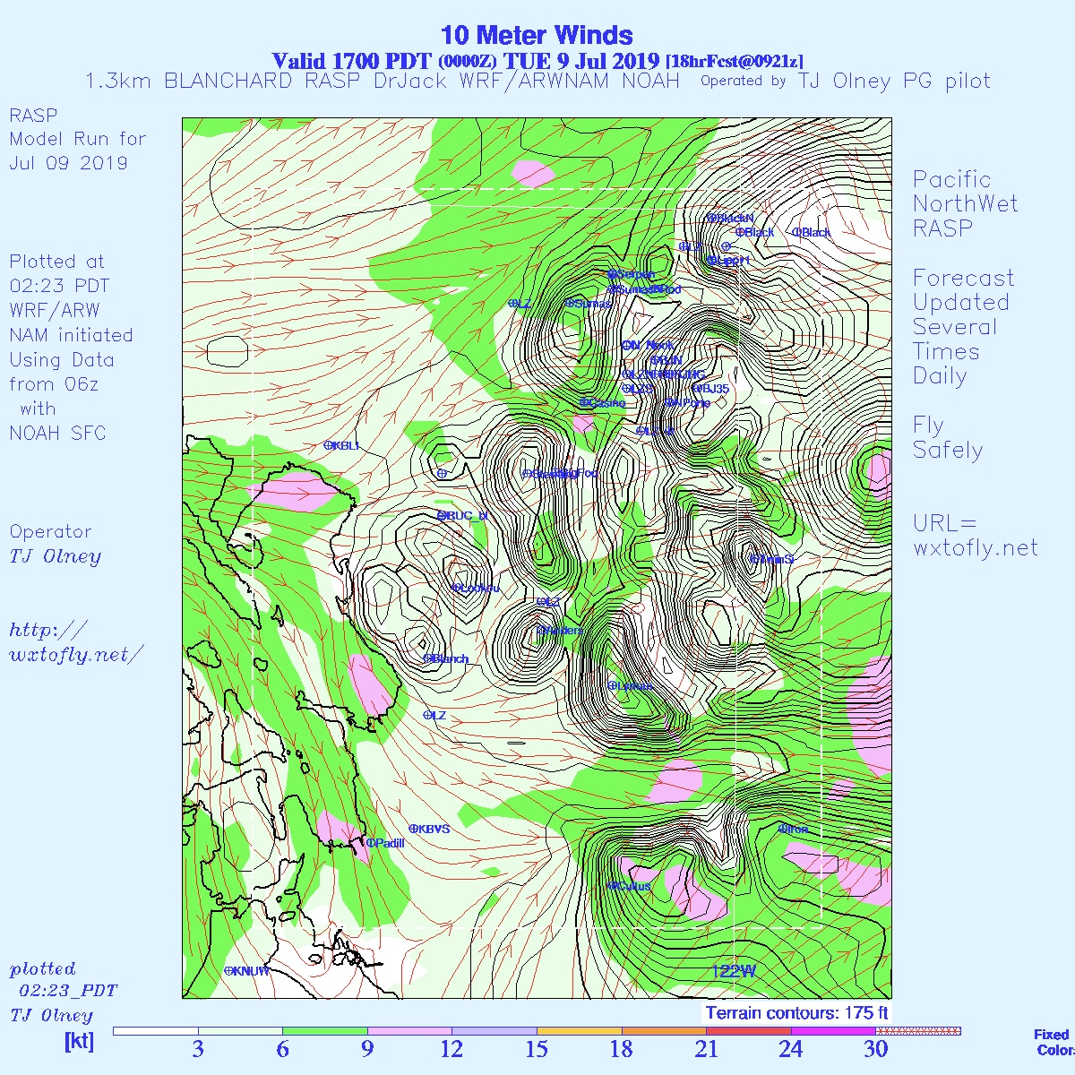

Lake Whatcom

* Bellingham sunrise, sunset, twilight, etc: <https://www.sunrisesunset.com/USA/Washington/Bellingham.asp>
* NOAA radar:

<http://radar.weather.gov/radar.php?rid=atx&product=N0R&overlay=11101111&loop=no>

* + I use this site to see if there are big storms coming in.
  + Note the wind usually precedes these storms.
* NOAA weather: [www.weather.gov](http://www.weather.gov)
  + Click on the graphs for more detailed information. Not so accurate for wind, but I like to look at this to see rain/snow/ice accumulation predictions.
  + This also shows if thunderstorms are predicted.
* NWS NWIC buoy (not sure when this will be online again)

<http://nvs.nanoos.org/Explorer?action=oiw:fixed_platform:NWIC_Bellinghambay:history>

* + This buoy is in the middle of Bellingham bay, but not uploaded regularly.
* Check the Canadian radar: <https://weather.gc.ca/radar/index_e.html?id=WUJ>
  + I check this one if I’m unsure of where the storm is coming from- this one broadens the search.
* KOMO interactive radar: <https://komonews.com/weather/radar>
  + Selecting the future scenario with precipitation can give you a general idea when the rain will arrive.
* NOAA Radar app by Apalon. You can use this to also see any approaching storm and how fast it is moving. (available in itunes and google play)
  + <https://www.apalon.com/noaa_radar_pro.html>
* Community Boating Center Post Point Buoy Webcam: <http://www.boatingcenter.org/post-point-web-camera/>

Sometimes the view gets skewed due to wind pushing the camera.

* Weather underground: [www.wunderground.com](http://www.wunderground.com)
  + Don’t use this for wind. It only shows the averages and the gusts are the most concerning.
* [www.ventusky.com](http://www.ventusky.com): Thanks to Paul R. This is a graphical presentation of the wind, and you can select different times to look at wind

Be careful when looking at weather sites that show averages only. It’s the gusts that you should be most concerned with.