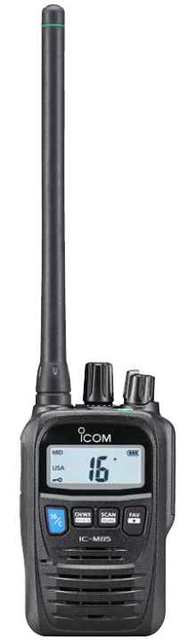

**Emergency call channel:** Tap to select for emergency calls.

**Transmit Key:** Hold down for 1 sec before speaking

**Lock Button and Icon:**

Tap on/off to change channel

**Tuning dial:** Rotate when selecting new channel

**Power & Volume dial:**

Rotate to turn on/off & adjust volume

**Battery indicator:** If low, place on charger during practice (NOT overnight)

**BASIC CARE AND USE:**

1. Do not carry the radio by the antenna.
2. Turn on radio and confirm the channel and battery level before launching.

* BBOP will use either channel **68** or channel **71**, depending on radio traffic
* To change the channel:
  + Unlock the radio by tapping the lock button
  + Hold the blue 16/C button for 1 sec until channel indicator blinks
  + Hold the blue 16/C button for 3 sec until two short beeps are heard
  + Rotate the tuning dial to the desired channel
  + Finish by pushing the 16/C button to select the call channel
  + Re-lock the radio by tapping the lock button, confirmed by the appearance of the lock icon.
* If the radio requires charging, place on the charger for the duration of practice **only**.

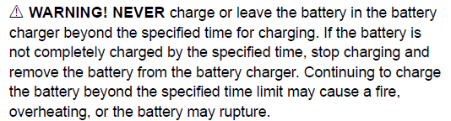

1. After use, rinse the radio thoroughly with freshwater and dry.

**IN CASE OF EMERGENCY:**

Contact other vessels and the Coast Guard by sending a Distress call on Channel 16. Use this procedure for your own crew as well as for other vessels.

**USING CHANNEL 16**

Push the blue 16/C button to select the emergency channel and transmit the following:

1. Press and hold the transmit button.

“MAYDAY MAYDAY MAYDAY”

1. Say your call sign and a brief description of the vessel.

“THIS IS 6-PERSON CANOE, **CALL SIGN OC6**. MAYDAY, OC6”

1. State your location simply and clearly.

“LOCATED AT …” E.G. NEAR SHORE, 1 MILE SOUTH OF POST POINT

1. State the nature of your emergency and assistance required.

”MEDICAL EMERGENCY FOR [#] PERSON/S WITH …”

EXAMPLES:

“MEDICAL EMERGENCY FOR 1 PERSON WITH SEVERE BLEEDING”

“MEDICAL EMERGENCY FOR 2 PERSONS IN THE WATER”

“VESSEL OVERTURNED AND SINKING. 6 SOULS IN THE WATER”

1. When a response is received, give any other information that might facilitate the rescue. Answer each question directly. Be clear and concise. Continue to use call signs.

EXAMPLES:

* “OC6 TO Terrapin: WE ARE DRIFTING 25 YARDS OFF THE TRAIN TUNNEL, OVER”
* “OC6 TO COAST GUARD: CONFIRMING RENDEVOUZ AT RED CHANNEL MARKER, OVER”